From Columbia, MO.
1. From Stadium and US-63 S head toward Jefferson City. (go 25.1 miles)
2. Merge onto US-54 W toward Jefferson City & Eldon. (go 13.9 miles)
3. Turn left onto Route E/MO-E, just past Brazito. (go 1.1 miles)
4. Stay straight onto Route H. (go 4.6 miles)
5. Take the left onto N Teal Bottom Rd at Fire Station. (go 2.0 miles)
6. Turn right to stay on N Teal Bottom Rd. (go 2.5 miles)
7. Straight on Scheuler Ferry Rd. gravel. (go 0.6 miles)
8. Turn left onto Channel Ln. gravel. (go 0.7 miles)
9. 16100 CHANNEL LN last bldg @ the end of the road……. Gated (16100)
16100 Channel Ln, Henley, MO 65040-2518
N 38 20.958, W 092 14.361 (573) 639-8556 or 289-0309
From Columbia @ Stadium & Hwy63; it’s apx. 1 hour / 50 miles
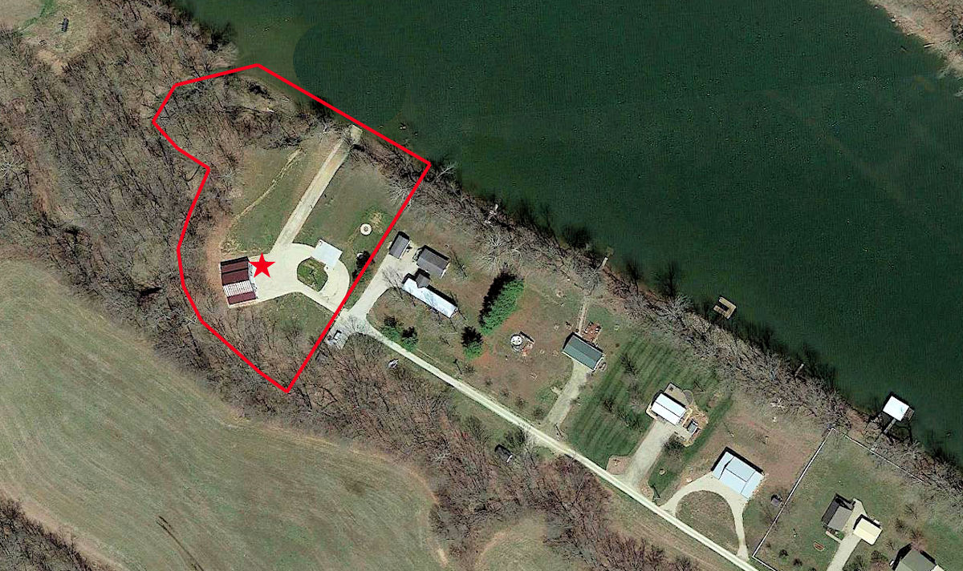
Bring BEER, We’re OUT……………….
